For more helpful and useful posts, visit our blog by clicking here

<https://learn-all-about.blogspot.com/>

Top Free Online Platform Sources from anyone can get education at any time by just having some Internet Connection in your devices like Mobile, Laptop, Computer PC, Tablets and much more.

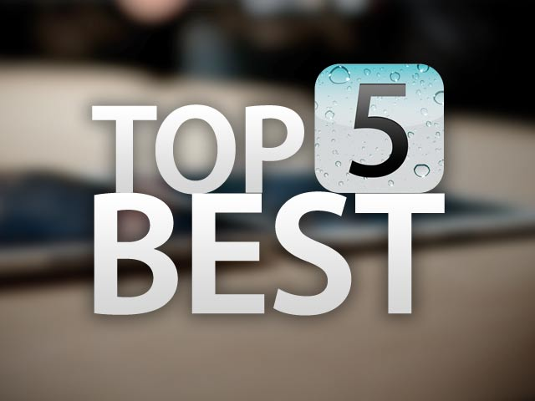

Whether you’re five or ninety five, the internet has a lot to offer. Particularly when the topic is education, the resources on the internet are endless. Best of all, many high quality sites are completely free. From history to coding, excellent free education awaits on the following some important and useful websites.

HERE WE HAD NOT INCLUDED EDUCATIONAL PLATFORM LIKE UDEMY, UDACITY,

PLURALSIGHTS,etc Because somehow there are paid courses and some are very few that are available for free.

FOR MORE HELPFUL AND USEFUL ARTICLES AND BLOGS, FEEL FREE TO SUBSCRIBE OUR BLOGSPOT.

OUR MOTTO AND VISION IS TO SPREAD KNOWLEDGE TO ALL OVER WORLD.

So, Lets lookup these websites:

1)  [EDX](http://edx.org/)

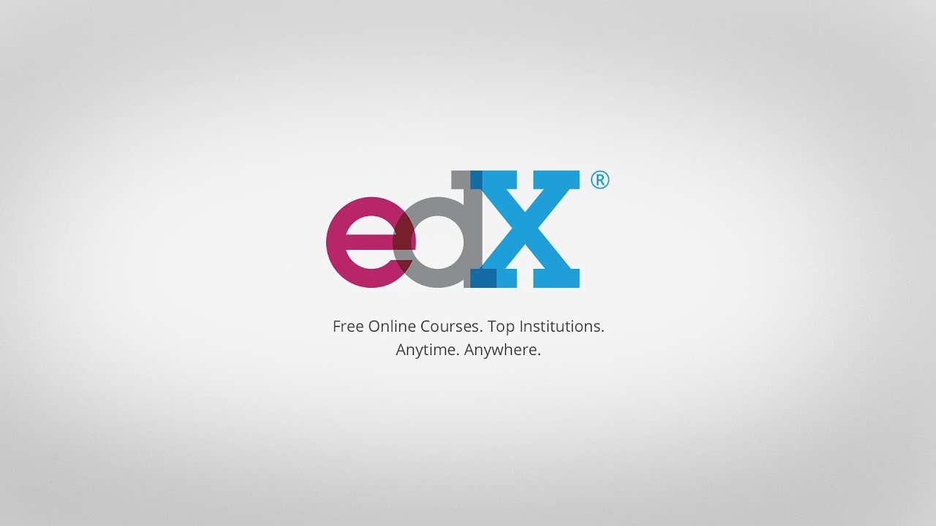

It is a great option for free online education. Also bringing together courses from many different schools, the site has impressive, quality information for everyone. edX covers a great range of topics.

Here, Giant Companies like Microsoft, Google and World's Reputed Institutes like Harvard University, Stanford University, IIT Bombay, IIT Madras, Michigan University, etc are providing Free Educational Coureses for everyone in different fields.

2) [COURSERA](http://coursera.org/)

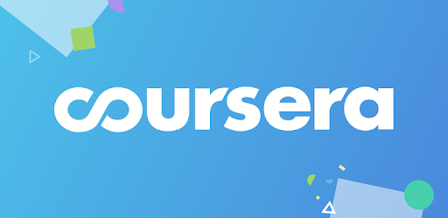

It is also a great option for free online education like edx. It is difficult to compare which is best between edx and coursera.

Like edx, Coursera also have Giants Companies and most reputed Institutions which they provides free educational courses on almost every field.

Coursera is a powerful tool for free online education, and includes courses from many top universities, museums and trusts. This gives the site an extremely wide range of in-depth courses. Coursera is extremely useful if you’re looking to study many different topics, or want courses from different schools and groups.

3) [ALISON](https://alison.com/)

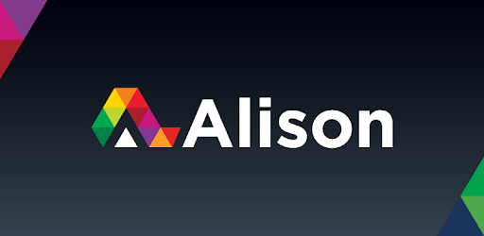

Alison is a free education site offering certification in some areas. Alison offers courses mainly in business, technology, and health, but also includes language learning courses. A great option if users need certification for their learning, Alison also offers school curriculum courses.

4) [W3Schools](https://www.w3schools.com/)

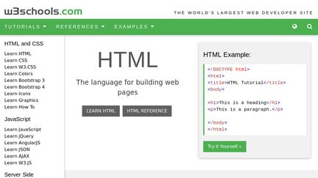

It is the best Online Website to learn Web Designing and Web Development from zero level to Highest level till it exist because it is the official organization to establish HTML 5 and its rules.

Here you can get to learn many designing and developing courses like:

* HTML and CSS
* JavaScript
* Server Side
* JAVA
* SQL
* PHP
* PYTHON
* ASP
* NODE.js
* RASPBERRY PI
* Web Building
* XML Tutorials.

5) [Khan Academy](https://www.khanacademy.org/)

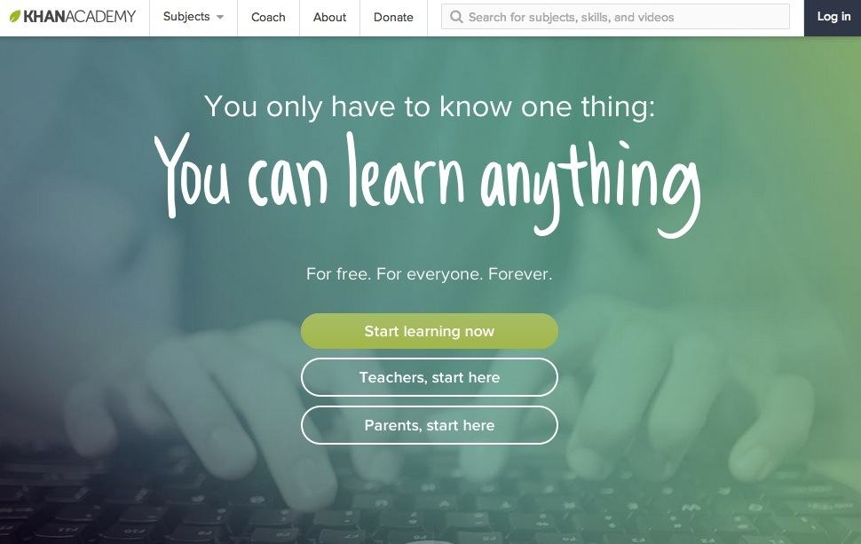

Partnering with many post secondary schools, Khan Academy offers a useable, well organized interface. Also curating many courses from around the web, Khan Academy offers impressive depth on many different subjects. Among the more well known educational sites, Khan Academy is also incredibly useable, which may make it easier to keep learning goals.

For more helpful and useful posts, visit our blog by clicking here

<https://learn-all-about.blogspot.com/>

IF THERE ARE ANY QUERIES OR ANY DOUBT, YOU ARE FREE TO ASK IN BELOW COMMENT SECTION.

THANKS YOU.

SHARE THIS TO SPREAD KNOWLEDGE FOR FREE TO ALL.

For more helpful and useful posts, visit our blog by clicking here

<https://learn-all-about.blogspot.com/>